## Darshan Nikam Date: 24/02/2024

### **Amazon S3 (Simple Storage Service)**

**Amazon S3 is like a giant digital storage unit provided by Amazon Web Services (AWS). It lets you store and retrieve any amount of data, at any time, from anywhere on the web.**

**Storage Infrastructure: S3 provides highly scalable, durable, and secure storage infrastructure in the cloud. It's designed to store and retrieve any amount of data from anywhere on the web.**

**Buckets and Objects: In S3, data is organized into "buckets" which are like containers for storing objects (files). Each object can range in size from a few bytes to terabytes. Think of a bucket as a main folder and objects as files stored within that folder.**

**Simple Interface: S3 offers a simple and intuitive interface for uploading, managing, and retrieving data. You can interact with S3 using the AWS Management Console, command-line interface (CLI), or software development kits (SDKs) for various programming languages.**

**Scalability: S3 is highly scalable, meaning it can handle large amounts of data and concurrent access requests. You can store virtually unlimited amounts of data in S3 without worrying about infrastructure management or capacity planning.**

**Durability and Availability: S3 is designed for durability and high availability. Your data is replicated across multiple data centers within a region, ensuring that it remains accessible even in the event of hardware failures or disasters.**

**Security: S3 offers several security features to protect your data, including access control lists (ACLs), bucket policies, and server-side encryption. You can control who can access your data and how they can access it, helping to ensure data privacy and compliance with regulations.**

**Cost-Effective: S3 follows a pay-as-you-go pricing model, where you only pay for the storage you use, the data you transfer in and out of S3, and any additional features or options you choose. There are no upfront fees or long-term commitments, making it cost-effective for businesses of all sizes.**

**Use Cases: S3 is used for a wide range of use cases, including data backup and archiving, website hosting, content distribution, application data storage, and big data analytics. It's a versatile storage solution suitable for various industries and applications.**

### **Now we create an S3 Bucket, upload a CSS template into the bucket, and host a Serverless Static Website.**

**Step 1) Sign in to your AWS Management Console, and go to S3 Service. Click on the Create Bucket button.**

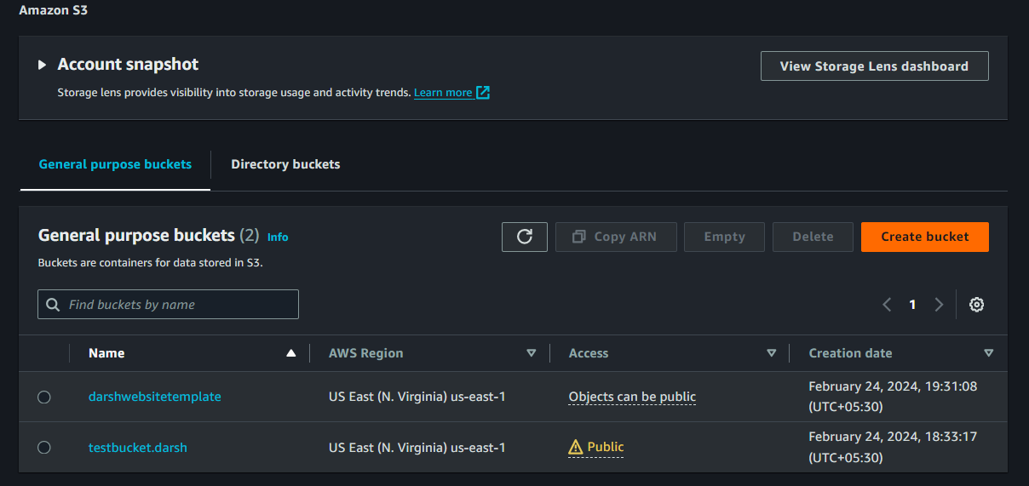

**Step 2) Select the AWS Region Where you want to create your bucket. Give your bucket name.**

**(The bucket name must be unique)**

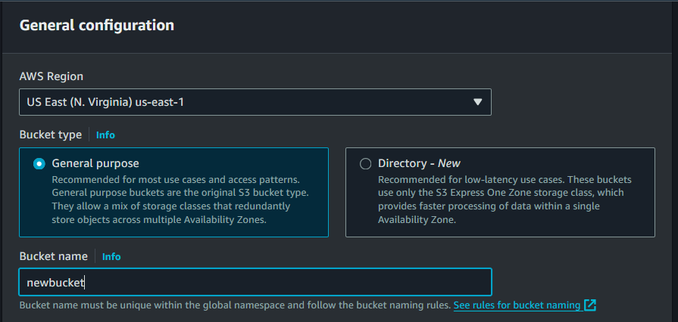

**Step 3) Select Object ownership as your requirement that determines who can specify to object.**

**And check or uncheck the public access. And accept acknowledge if uncheck the box. (For static websites we need ACLs enabled)**

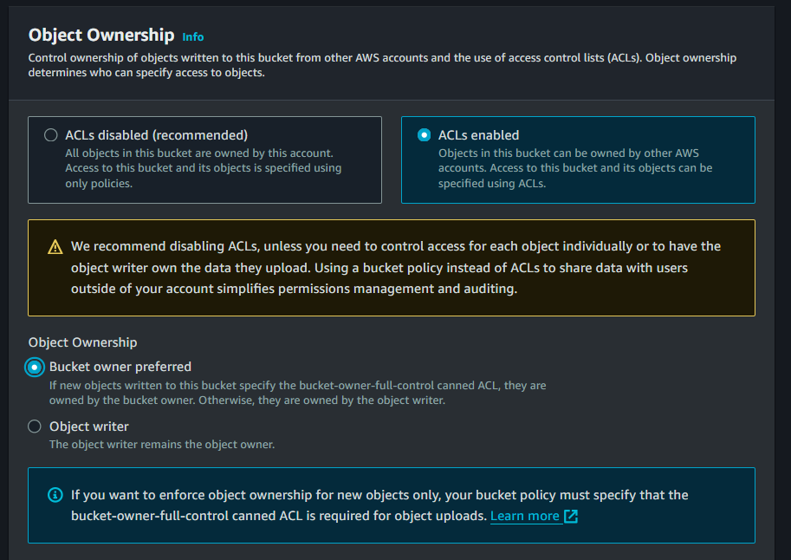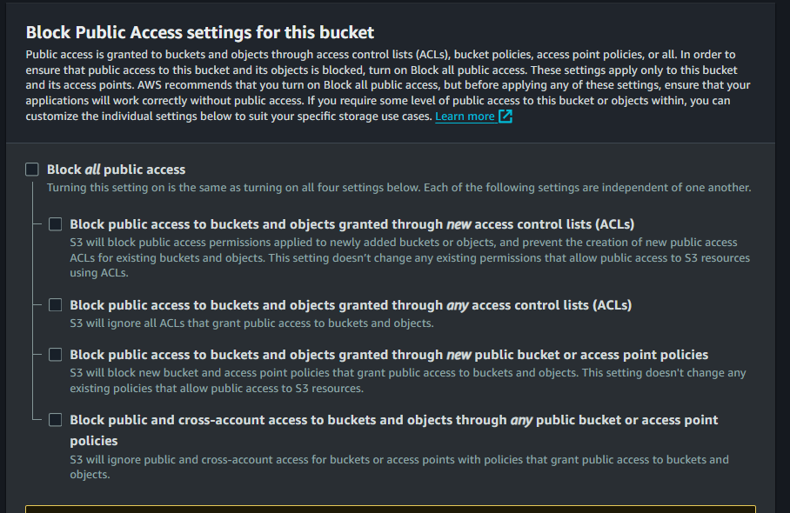

**Step 4) Bucket versioning is the option for keeping multiple variants of an object in the same bucket, as your requirement you can enable or disable this option.**

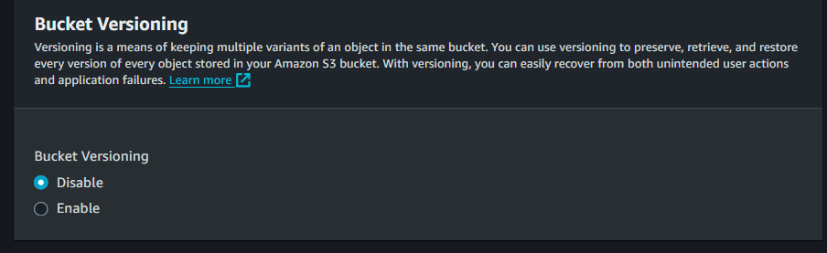

**Step 5) Click on the Create Bucket Button.**

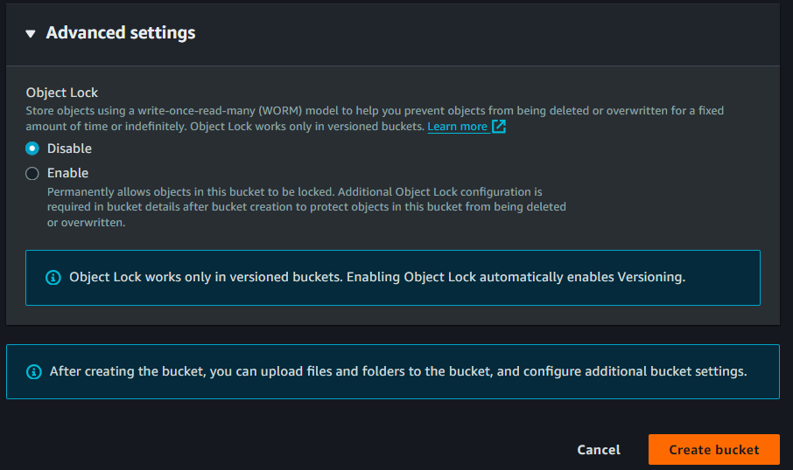

**Now you will see bucket is created.**

**Step 5) Once the Bucket is created, click on its name to open it. And click on the Upload button.**

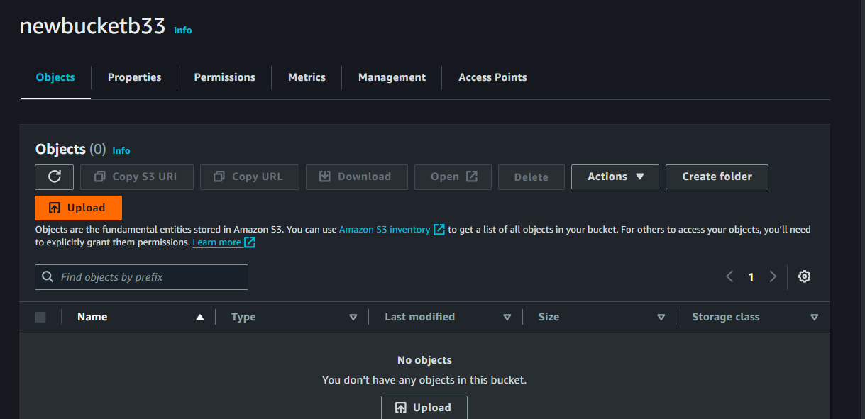

**Step 6) Click on the Add Files button to select the file you want to upload, or simply Drag & Drop files.**

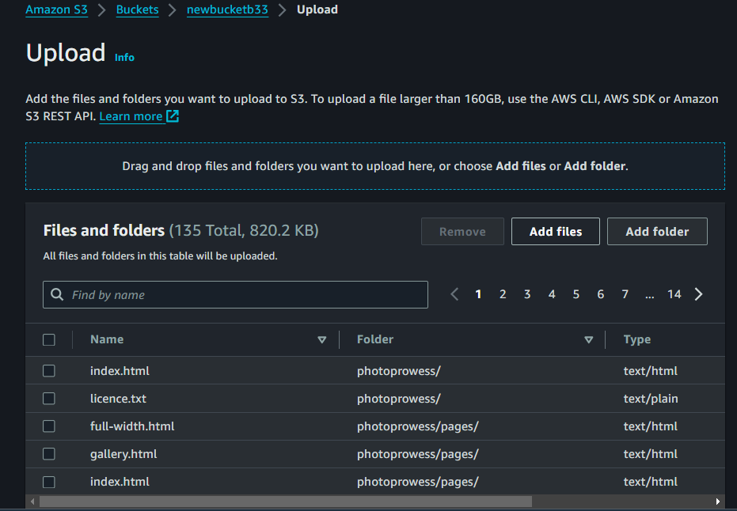

**Step 6) Now set the Access Permissions. And accept the warning message.**

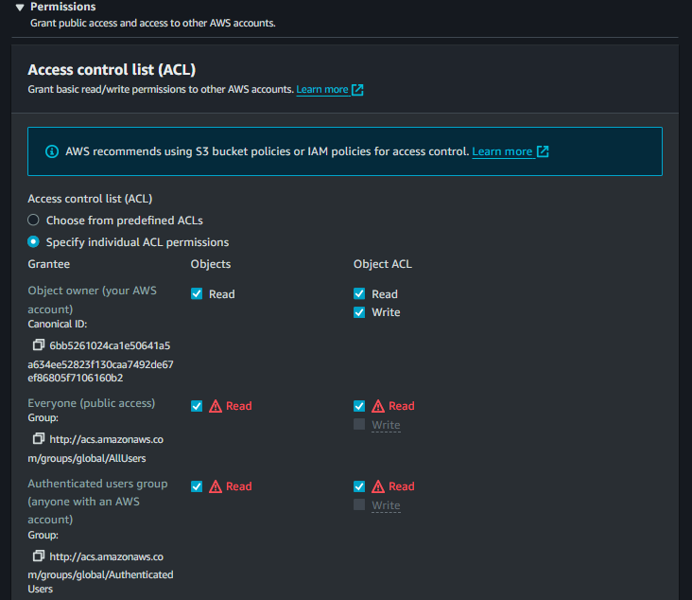

**Step 7) Select Storage Class. As your use case.**

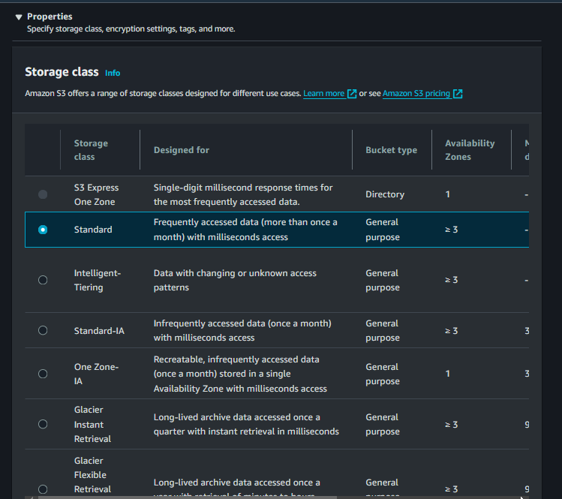

**Step 8) You can Specify Server-side encryption to encrypt the newly uploaded objects automatically when they are uploaded.**

**When you configure the server-side encryption setting of your object, you can either use the default encryption bucket settings or specify an encryption key.**

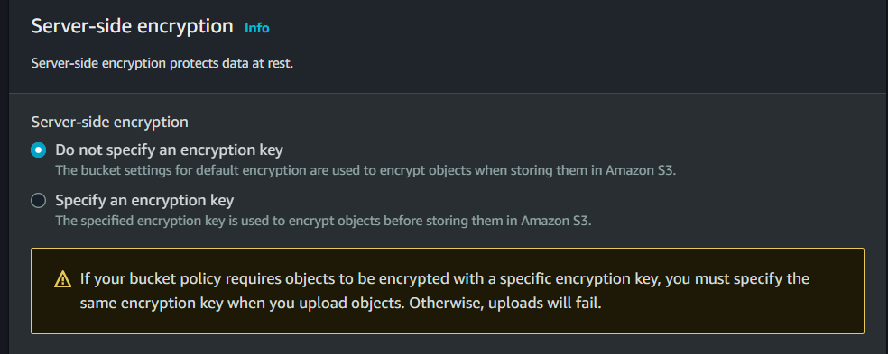

**Step 9) Click on the Upload Button. The files will begin uploading and you will receive a notification when the job is complete.**

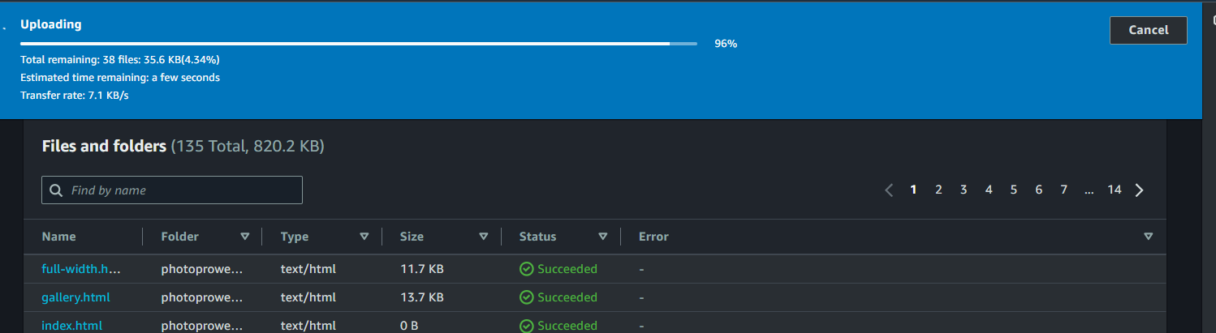

**Step 10) Now go back into your bucket and click on Properties. Then click on the Edit Button of the Static website hosting option.**

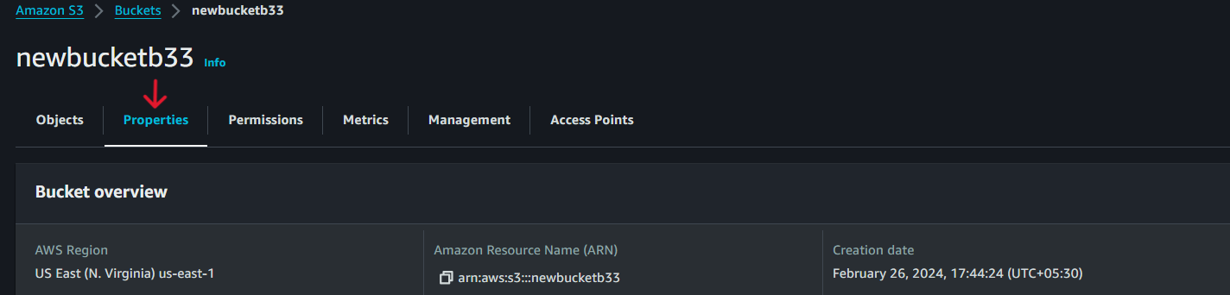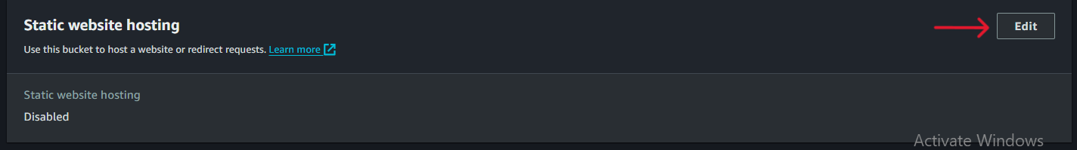

**Step 11) Simply Enable the service, and click on the save changes button.**

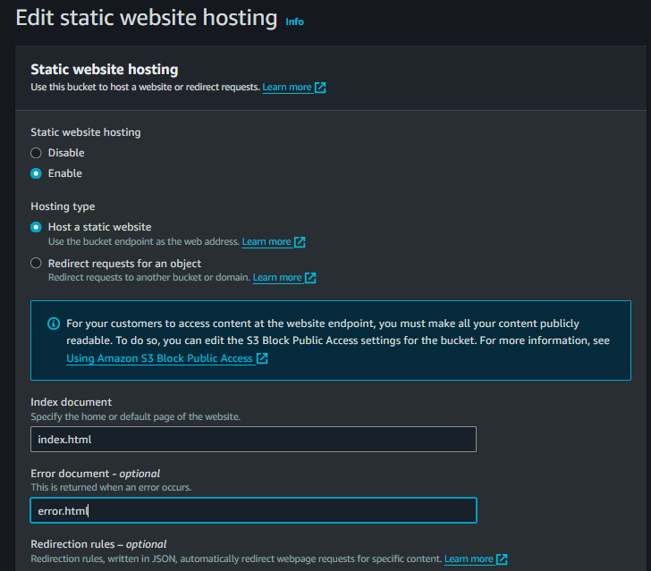

**Now your Static website is enabled and you will get the URL of your bucket object, to access the object using this URL you need to create a Bucket policy.**

**Step 12) Go to Bucket Permissions and click on the Bucket Policy Edit button then Click on Policy Generator Button.**

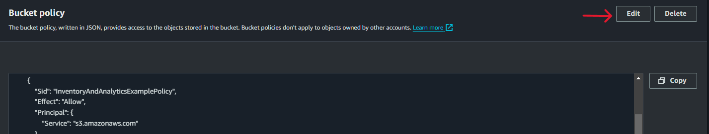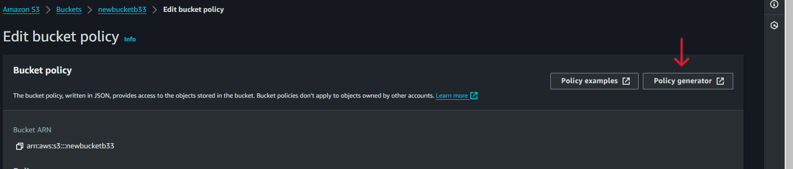

**AWS Policy Generator Page will open.**

**Step 13) Select Policy Type “S3 Bucket policy” Add Statement “ * ” for all Principal, Select Action you to allow, then enter the ARN of Bucket and Click on the Add Statement Button. Then click on the Generate Policy Button**

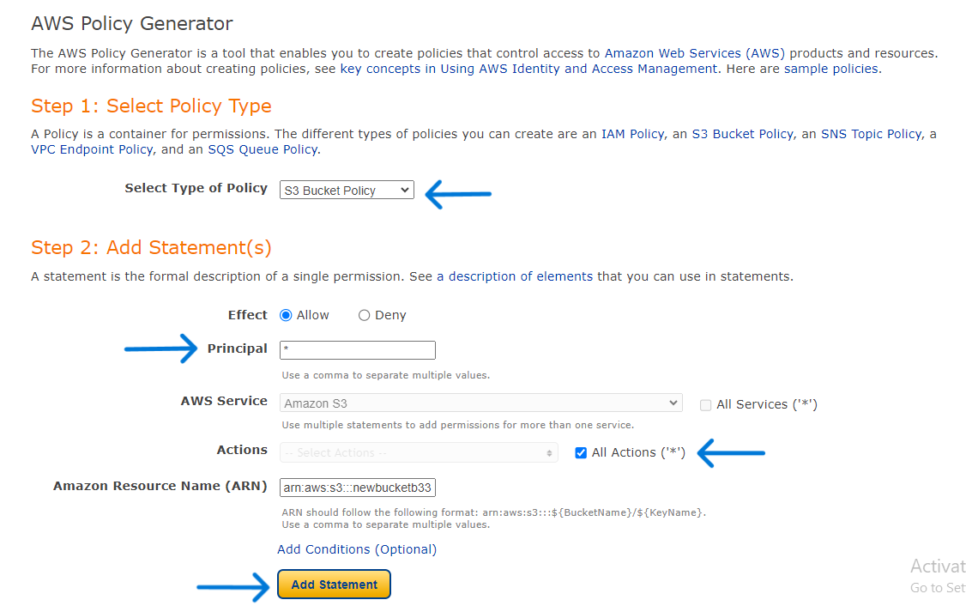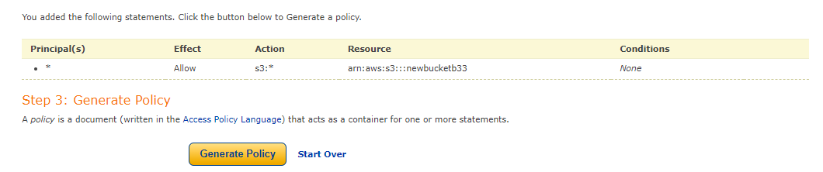

**Step 14) Now your Policy will generated in JSON Format, Simply copy the policy and go back to your policy edit tab.**

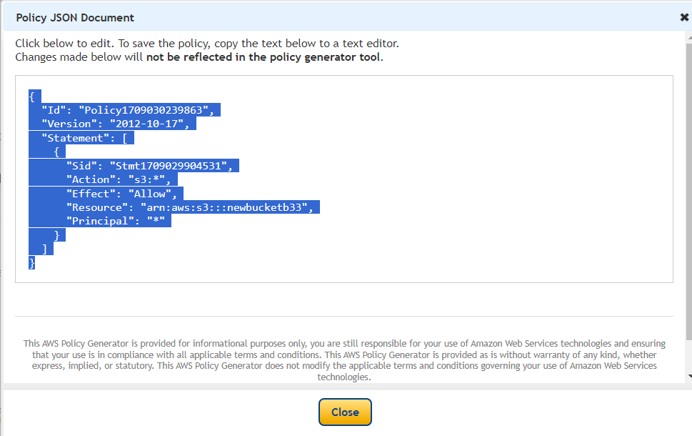

**Step 15) Paste your Policy, type “ /* ” into the end of the resource line before ” and click on the save changes button.**

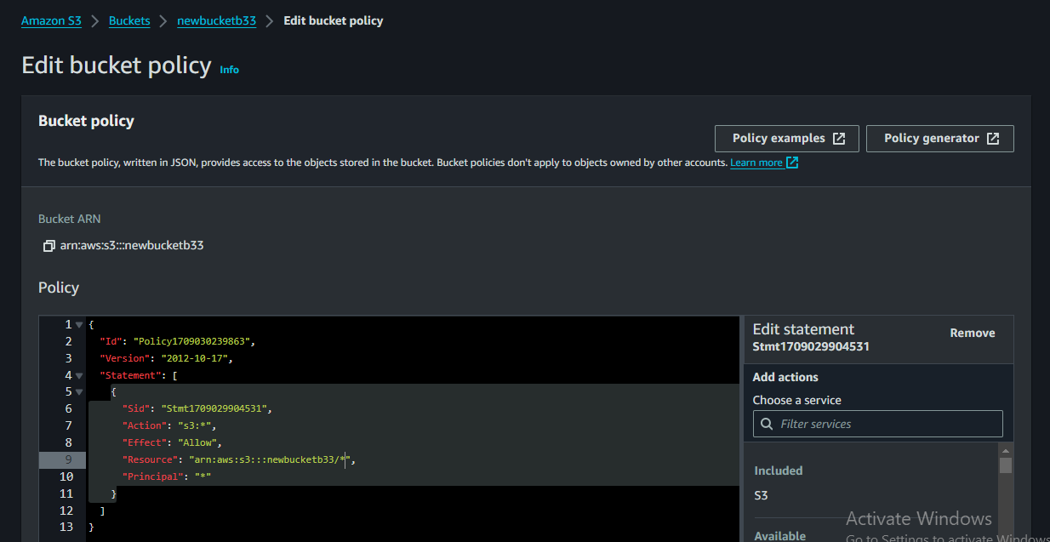

**Now your Object is public, copy the static website URL and paste it into a new tab your static website will open.**

**AWS S3 Buckets Other Services and option**

1. ***Server Less Access Login:* Server access logging provides detailed records for the requests that are made to a bucket. Server access logs are useful for many applications. For example, access log information can be useful in security and access audits. This information can also help you learn about your customer base and understand your Amazon S3 bill.**
2. ***Object Ownership:* When you have created a bucket and ACL is not enabled then go to Permission Setting and select the Bucket ownership option and click on the Edit button and enable ACL. Then click the save changes button.**

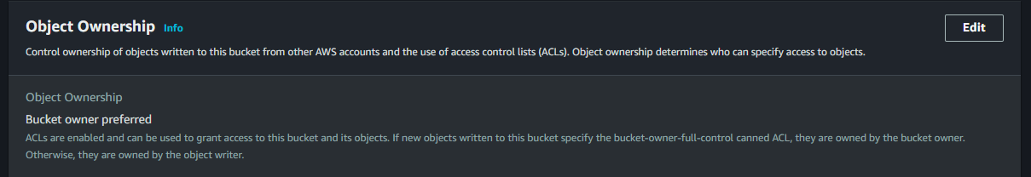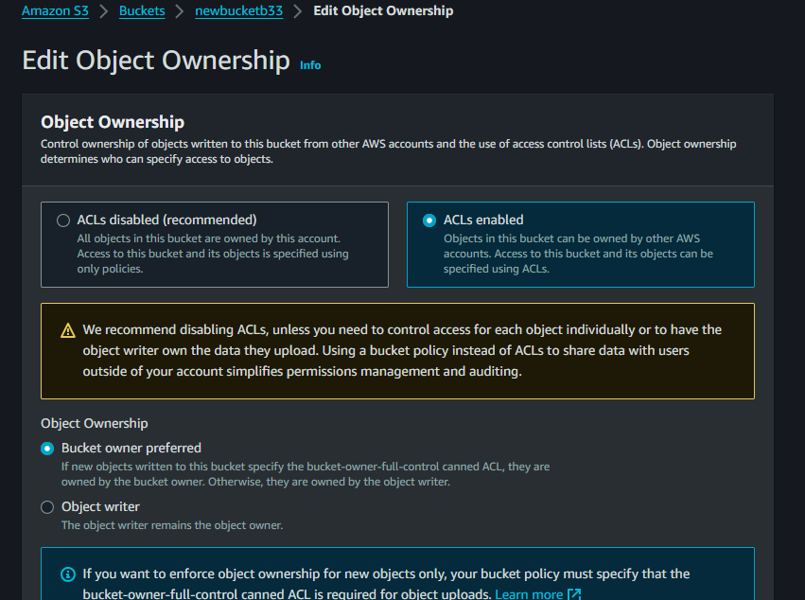

1. ***Management Option:* Have a 3 fields**
2. ***Life Cycle rule:* To manage your objects so that they are stored cost effectively throughout their lifecycle, configure their Amazon S3 Lifecycle. An S3 Lifecycle configuration is a set of rules that define actions that Amazon S3 applies to a group of objects. There are two types of actions:**
3. **Transition actions – These actions define when objects transition to another storage class. For example, you might choose to transition objects to the S3 Standard-IA storage class 30 days after creating them, or archive objects to the S3 Glacier Flexible Retrieval storage class one year after creating them.**
4. **Expiration actions – These actions define when objects expire. Amazon S3 deletes expired objects on your behalf. Lifecycle expiration costs depend on when you choose to expire objects.**
5. **Click on Create Lifecycle Rule.**

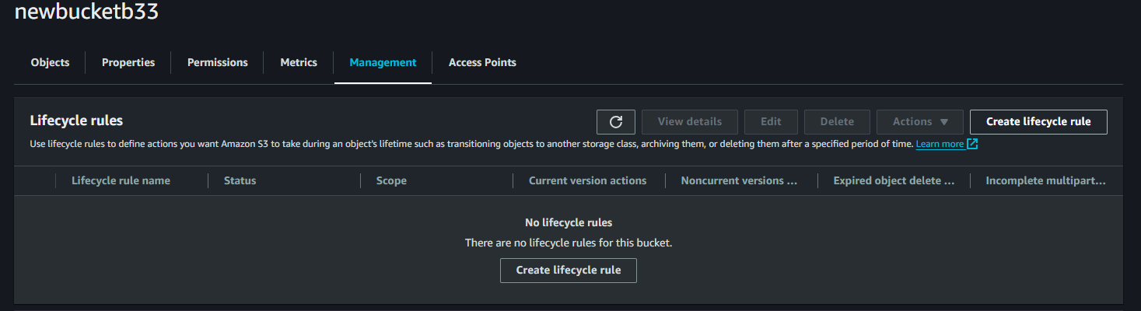

1. **Configure the rule by your use case. And click on the Create Rule button.**

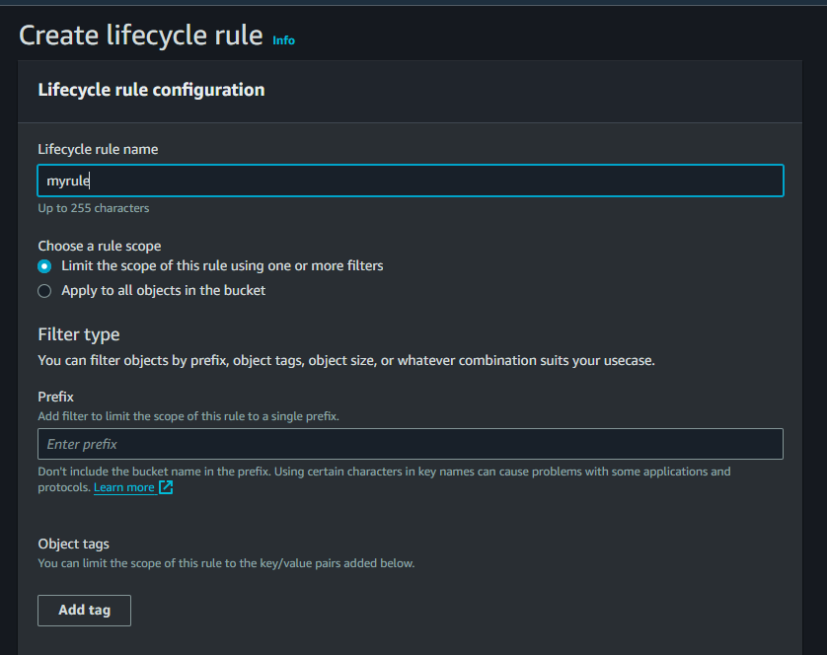

1. ***Replication Rule:* Replication enables automatic, asynchronous copying of objects across Amazon S3**

**buckets. Buckets that are configured for object replication can be owned by the same AWS account or by different accounts. You can replicate objects to a single destination bucket or to multiple destination buckets. The destination buckets can be in different AWS Regions or within the same Region as the source bucket**

1. **Click on Create Replication Rule. Enable Versioning, And enter your rule name.**
2. **Your source bucket details will show, Choose the rule scope.**
3. **Select Destination Bucket by clicking on the Browse button and also have the option to another AWS account.**
4. **Click on Create new IAM Role.**
5. **More additional options are available, if want to encrypt your data you enable this option. And also have option to select storage class.**
6. **Simply Click on the save role button.**

**.**

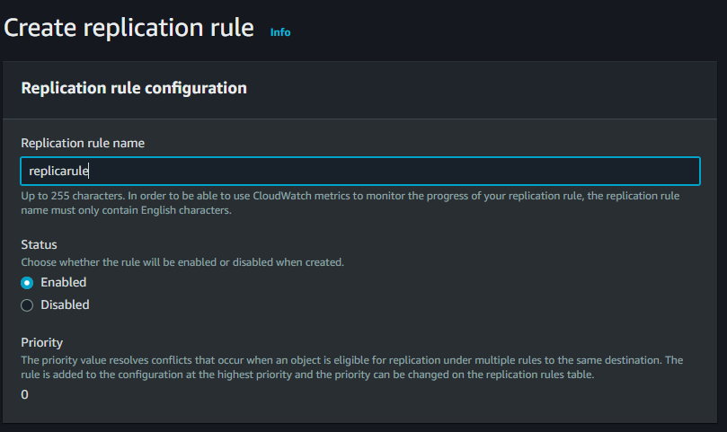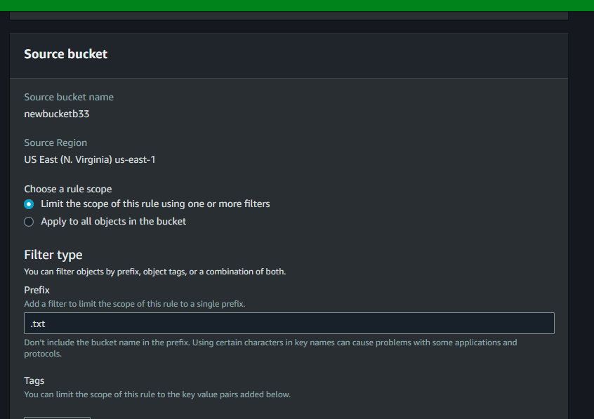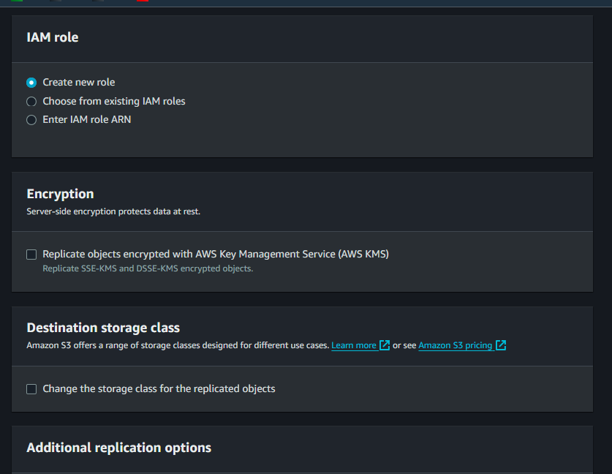

1. ***Inventory Configuration:* You can use Amazon S3 Inventory to help manage your storage. For example, you can use it to audit and report on the replication and encryption status of your objects for business, compliance, and regulatory needs. You can also simplify and speed up business workflows and big data jobs by using Amazon S3 Inventory, which provides a scheduled alternative to the Amazon S3 synchronous List API operations.**